Client-Server Architecture

Example of UML diagram in client-server architecture (chat application):
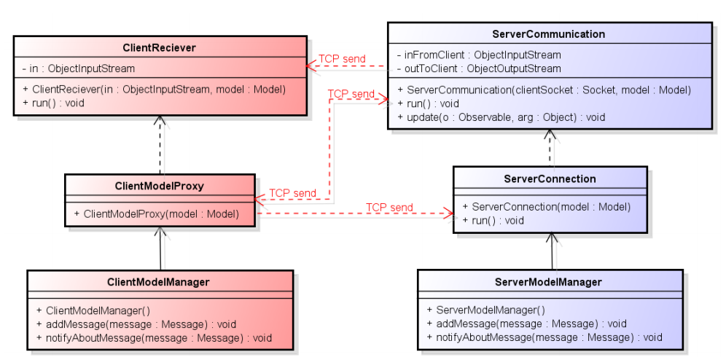

General description of Client-Server:
- Client-server architecture (client/server) is a network architecture in which each computer or process on the network is either a client or a server. Servers are powerful computers or processes dedicated to managing disk drives (file servers), printers (print servers), or network traffic (network servers ). Clients are PCs or workstations on which users run applications. Clients rely on servers for resources, such as files, devices, and even processing power.
Client-Server using Java sockets:
- Server:
  - On server side the port number needs to be specified. Following is to create welcome socked. “ServerSocket welcomeSocket = new ServerSocket(PORT);”. Welcome socket is used to “welcome” clients who try to connect to the server. When the client connects to the server, the connection controller is created “Socket connectionSocket = welcomeSocket.accept();”. Connection controller is used to create ObjectStreams. Those send and receive objects from client.
  - // create output stream attached to the socket ObjectOutputStream outToClient = new ObjectOutputStream( connectionSocket.getOutputStream());
  - // create input stream attached to the socket ObjectInputStream inFromClient = new ObjectInputStream( (connectionSocket.getInputStream()));
  - Reading an sending objects from clients is done by writeObject() and readObject methods from ObjectStreams.
- Client:
  - Client is done in similar way. To create connection it needs to know port number used on server and servers IP address. “Socket clientSocket = new Socket(HOST, PORT);”. After the client socket is created, ObjectStreams are created in similiar way as in server, only using clientSocket.
Client-Server according to UML diagram:
- Class server connection is responsible for starting the server and waiting for the clients to connect. After the client connects to the server, the instance of serverCommunication class is created with connectionSocket.
- Class serverCommunication is responsible for creating object streams and communication with client.
- Class clientModelProxy is responsible for connecting to the server and creating clientReceiver.
- Class clientReceiver is receiving objects from server and passing them to the client system.

Our implementation of Client-Server:
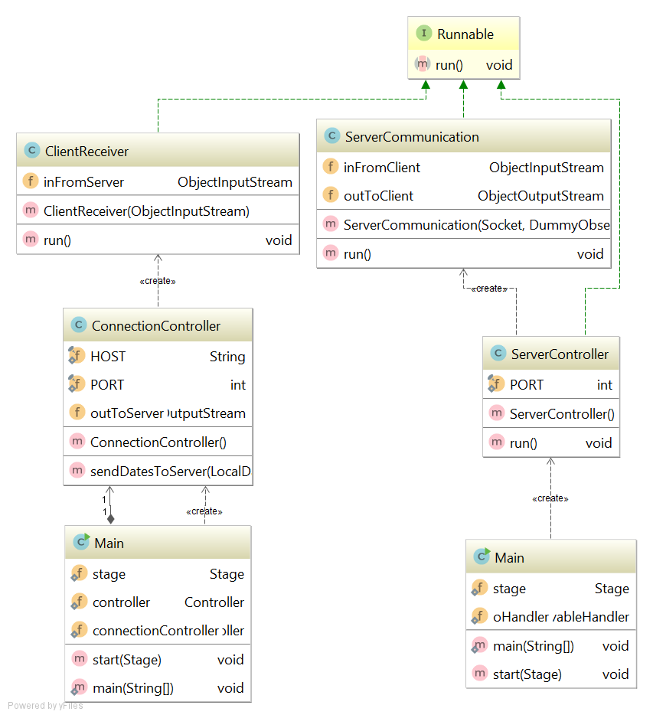

Description of our implementation:
- Server:
  - After the main class creates serverController the welcome socket is created and sever controller waits for clients to connect.
  - When client connects, serverCommunication is created. After that the current trip list is sent to the client and then the class waits for dates from client side which are then passed to the different part of the system to be handled.
  - Other parts of the system responsible for sending objects to clients are DataHandler and DummyObserver.
- Client:
  - The connection controller connects to the server and creates object streams and client receiver.
  - Client receiver is expecting ProxyTripList object from list. When it is received, the list is displayed in client GUI.
Code examples:
- Class ServerController
public class ServerController implements Runnable {
private static final int PORT = 6666;
public void run() {
int count = 1;
try {
ServerSocket welcomeSocket = new ServerSocket(PORT);
System.out.println("Server started");
DummyObserver observer = new DummyObserver();
while (true) {
Socket connectionSocket = welcomeSocket.accept();
ServerCommunication c = new ServerCommunication(connectionSocket, observer);
new Thread(c, "Communication " + count).start();
count++;
}
} catch (Exception e) {
e.printStackTrace();
}
}
}

- Run method from class ServerCommunication.

- public void run() {
try {
outToClient.writeObject(DataHandler.getInstance().getTrips());
outToClient.reset();
} catch (IOException e) {
e.printStackTrace();
}
while (true) {
try {
LocalDate[] dates = (LocalDate[]) inFromClient.readObject();
DataHandler.getInstance().getInDates(dates, outToClient);
inFromClient.reset();
} catch (IOException e) {
//
} catch (ClassNotFoundException e) {
//
}
}
}

- Contructor of ConnectionController

public ConnectionController() throws IOException {
try {
Socket socket = new Socket(HOST, PORT);
outToServer = new ObjectOutputStream(socket.getOutputStream());
ObjectInputStream inFromServer = new ObjectInputStream(socket.getInputStream());
ClientReceiver reciever = new ClientReceiver(inFromServer);
new Thread(reciever, "Reciever").start();
} catch (Exception e) {
e.printStackTrace();
}
}

- Run method from ClientReceiver
- @Override
public void run() {
while (true) {
try {
ProxyTripList trips = (ProxyTripList) inFromServer.readObject();
Main.controller.showList(trips);
} catch (IOException | ClassNotFoundException e) {
e.printStackTrace();
}
}
}

Model-View-Controller design pattern

General diagram for MVC design pattern:
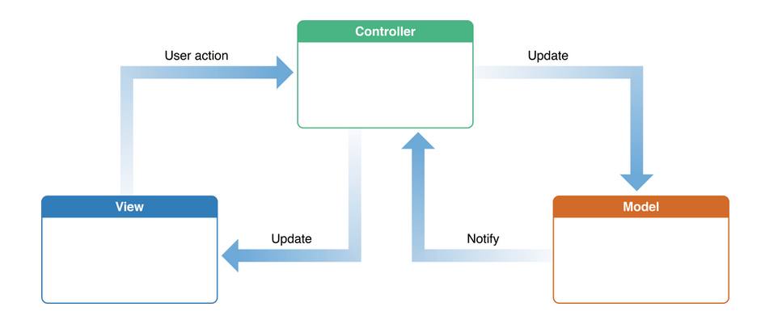

MVC description:

- The Model-View-Controller (MVC) design pattern assigns objects in an application one of three roles: model, view, or controller. The pattern defines not only the roles objects play in the application, it defines the way objects communicate with each other.
- Controller
  - Controllers act as an interface between Model and View components to process all the logic and requests, manipulate data using the Model component and interact with the Views to show the final output.
- View
  - Views are responsible for displaying all or a portion of the data to the user.
- Model
  - Model corresponds to all the data-related logic that the user works with. This can represent either the data that is being transferred between the View and Controller components or any other logic-related data.

Our implementation:
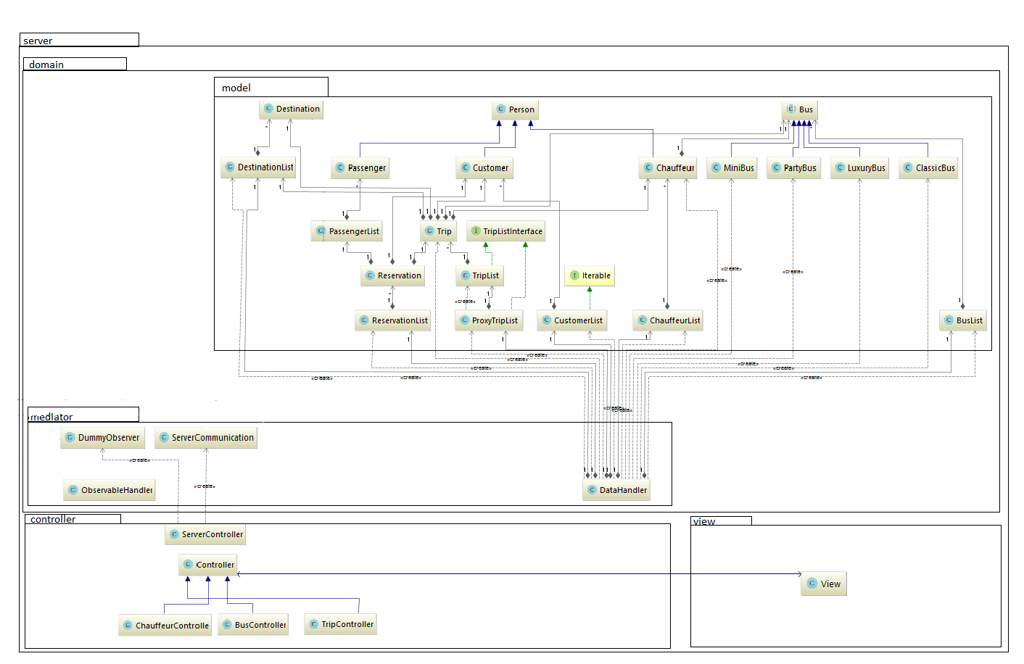
- Controller (BusController)
private void loadList() {
busListview.getSelectionModel().setSelectionMode(SelectionMode.MULTIPLE);
ObservableList<Bus> items = DataHandler.getInstance().getObservableListOfBuses();
busListview.setItems(items);
}
/**
* Deletes selected buses from list of buses.
*/
public void deleteBus(ActionEvent actionEvent) throws FileNotFoundException, ParseException {
ObservableList<Bus> selected;
selected = busListview.getSelectionModel().getSelectedItems();
for (Bus aSelected : selected) {
DataHandler.getInstance().removeFromBuslist(aSelected);
}
loadList();
DataHandler.getInstance().save();
}
}
}

- BusController delegates work to DataHandler from mediator package in order to get all data it needs to display something in GUI, or to create new objects of classes in model package.

- DataHandler class:
public void removeFromBuslist(Bus bus) {
busList.removeBus(bus);
}

public ObservableList getObservableListOfBuses() {
ObservableList<Bus> items = FXCollections.observableArrayList();
for (Bus bus : busList.getArrayBuses()) {
items.add(bus);
}
return items;
}

- DataHandler solves the tasks by accessing the model and it contains all the necessary methods to mediate work from controller classes to model classes.

- The package View contains all fxml files for all different screens in the system. Those do not have access to anything else in the system, and are controlled by corresponding classes in the Controller package.

Façade

An example of UML class diagram for façade design pattern:
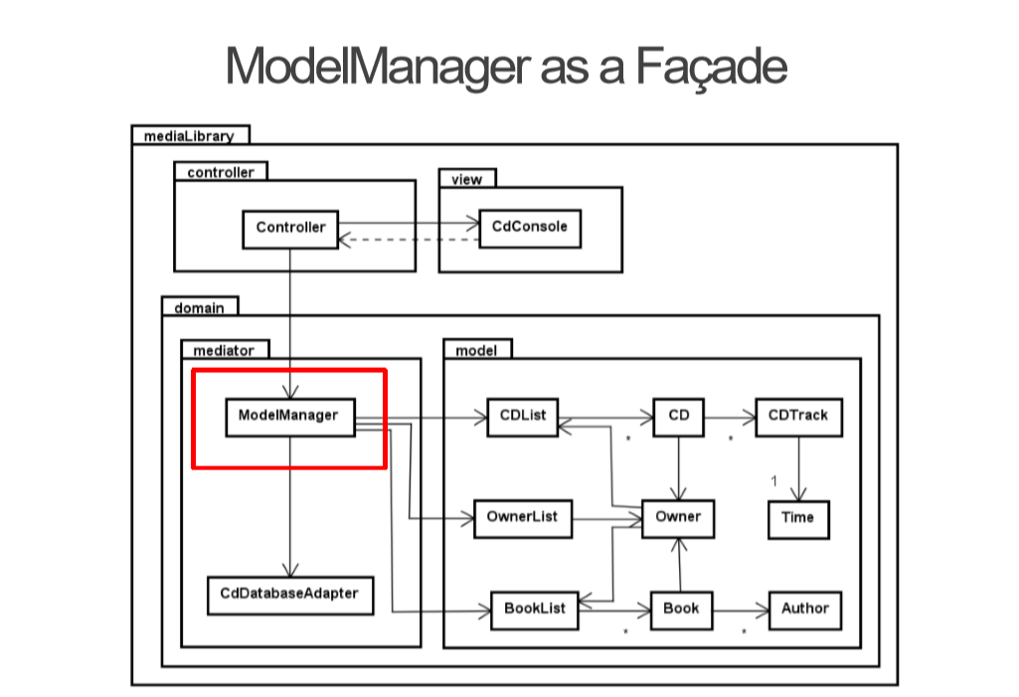

The overall purpose for the Façade design pattern:
- Facade pattern hides the complexities of the system and provides an interface to the client using which the client can access the system. This type of design pattern comes under structural pattern as this pattern adds an interface to existing system to hide its complexities.
Description of example UML diagram:
- The ModelManager is the façade for model having model state (and additional actions).
- The intent of façade is to provide an interface with simplified methods required by client which delegate calls to methods of existing system classes.
- Facade shows how to make a single object represent an entire subsystem.

Usage of façade design pattern:
- When client wants to access data from the model, the model manager method is called and model manager does the job of accessing model data.
- Façade design pattern does not require to have interface for façade class.

Our implementation:
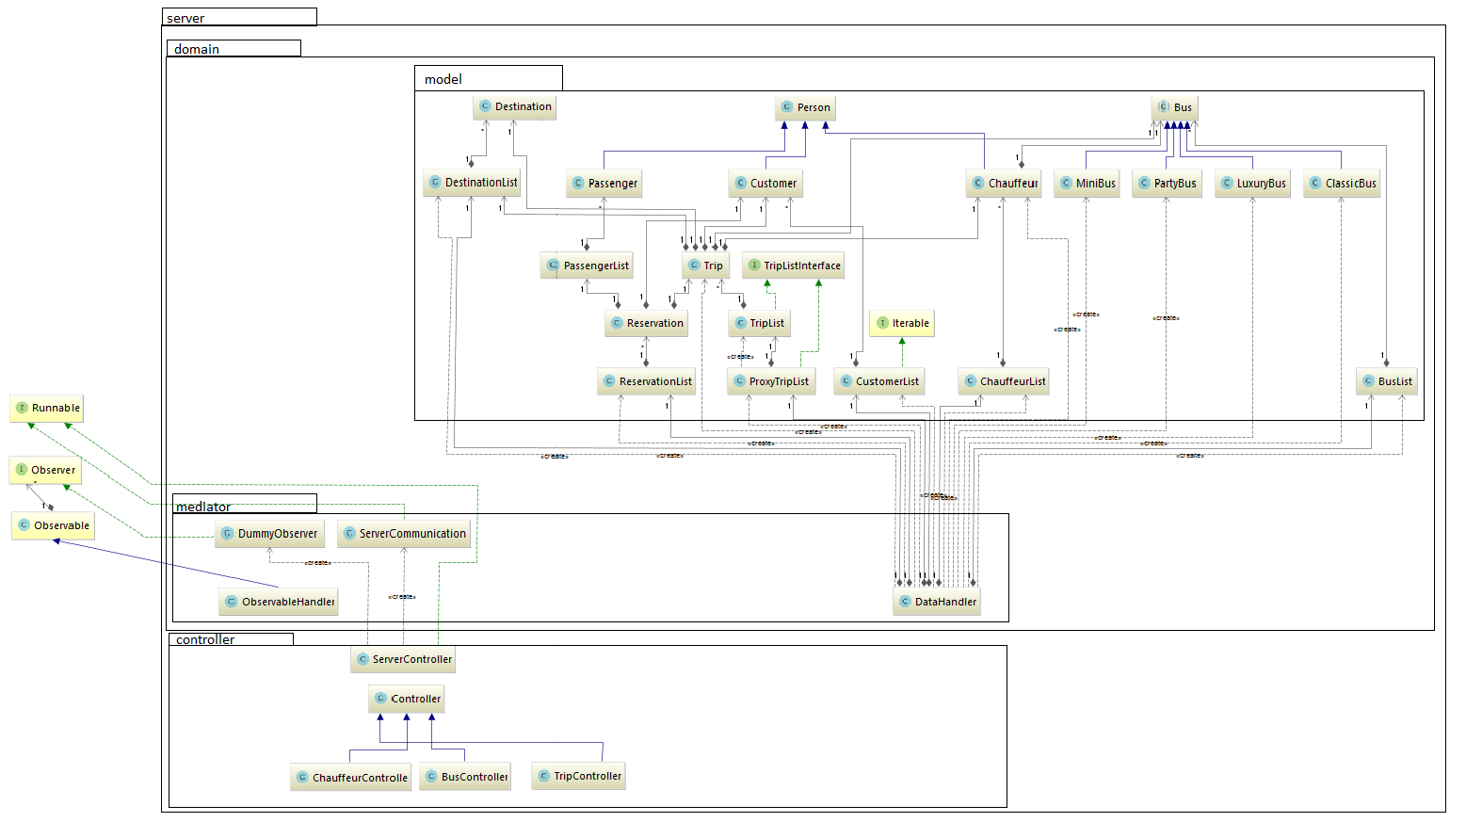

- In our system, the data is controlled through one class called DataHandler. The user is able to access all the data through this class. It doesn’t use an interface like it is shown on the original diagram. When the client wants to access the list of tours from his computer, The DataHandler class allows the user to get their list of information in one call by creating an object of type DataHandler.
Code example:
- Method load from data handler loads data from file and stores them inside
public void load() {
String filename = "mainData.bin";
ObjectInputStream in = null;
try {
File file = new File(filename);
FileInputStream fis = new FileInputStream(file);
in = new ObjectInputStream(fis);
trips = (ProxyTripList) in.readObject();
busList = (BusList) in.readObject();
chauffeurList = (ChauffeurList) in.readObject();
customerList = (CustomerList) in.readObject();
reservationList = (ReservationList) in.readObject();
destinationList = (DestinationList) in.readObject();
} catch (ClassCastException | IOException | ClassNotFoundException e) {
testCreate();
} finally {
try {
if (in != null) {
in.close();
}
} catch (IOException e) {
e.printStackTrace();
}
}
}

- User can call getter methods to get model data
public ProxyTripList getTrips() {
return trips;
}

- Or controllers call methods to get ObservableLists<> in order to display data in GUI
public ObservableList getObservableListOfBuses() {
ObservableList<Bus> items = FXCollections.observableArrayList();
for (Bus bus : busList.getArrayBuses()) {
items.add(bus);
}
return items;
}

Singleton design pattern

General UML class diagram for singleton design pattern:
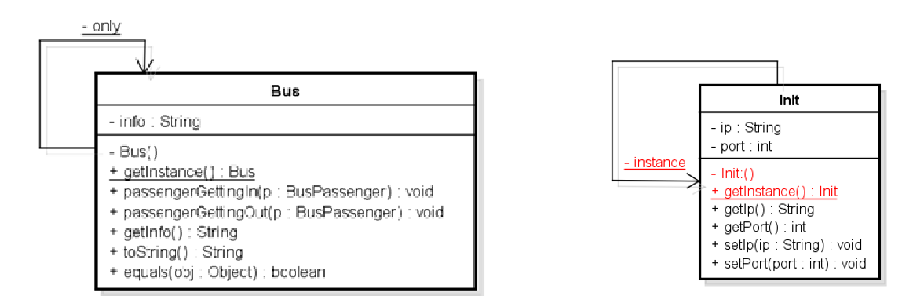
The overall purpose for the singleton design pattern:
- Singleton involves a single class which is responsible to create an object while making sure that only single object gets created. This class provides a way to access its only object which can be accessed directly without need to instantiate the object of the class.
Criteria for singleton:
- private static Singleton instance - Private static class variable of the same type as the class that is the only instance of the class.
- private Singleton() – Private constructor to restrict instantiation of the class from other classes.
- public static Singleton getInstance() – Public static class method returning an instance of the class, this method has to ensure that only one instance is create. This is the global access point for outer world to get the instance of the singleton class.

Usage of singleton design pattern:
- Singleton pattern is mostly used in multi-threaded and database applications. It is used in logging, caching, thread pools, configuration settings etc.
- To use the singleton class, we need to have static member of class, private constructor and static factory method.
  - Static member: It gets memory only once because of static, it contains the instance of the Singleton class.
  - Private constructor: It will prevent to instantiate the Singleton class from outside the class.
  - Static method: This provides the global point of access to the Singleton object and returns the instance to the caller.

Our implementation:
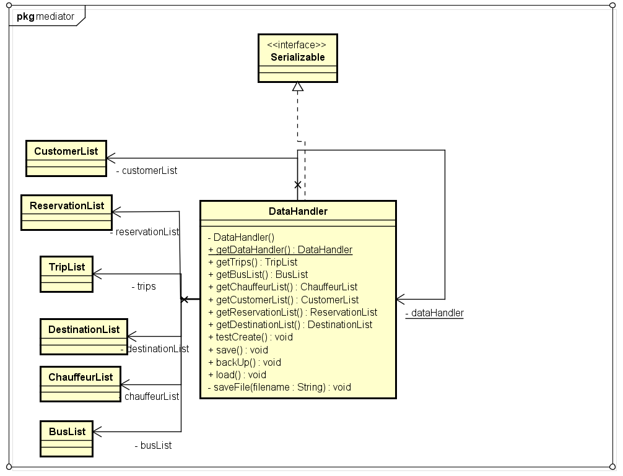

Code example:
public class DataHandler implements Serializable {
public static final char CLASSIC = 'c';
public static final char LUXURY = 'l';
public static final char PARTY = 'p';
public static final char MINI = 'm';
private static DataHandler dataHandler;
private ProxyTripList trips;
private BusList busList;
private ChauffeurList chauffeurList;
private CustomerList customerList;
private ReservationList reservationList;
private DestinationList destinationList;
private DataHandler() {
}
public static DataHandler getInstance() {
if (dataHandler == null) {
dataHandler = new DataHandler();
}
return dataHandler;
}
- We have inserted printout statement in the getInstance() method in which we are printing hashcode of datahandler object to the console. By doing this we can easily see if we are using only one instance of datahandler in the whole project.
- After running project and trying several parts of program, we got following output in the console:
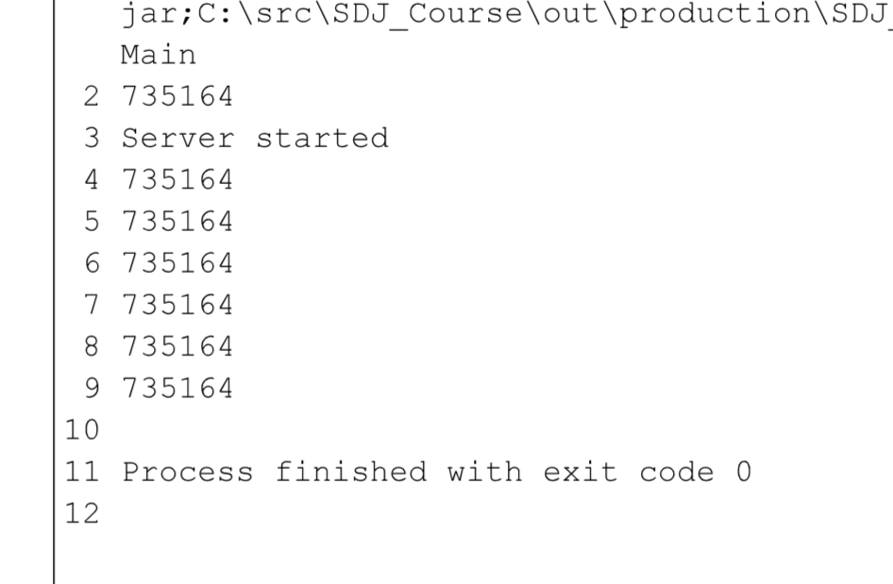

- Number 735164 is the hashcode of the datahandler instance. Since the number is the same in all printouts, we consider test as success, we conclude that we have implemented singleton design pattern correctly.

Observer design pattern

General UML diagram for observer design pattern:

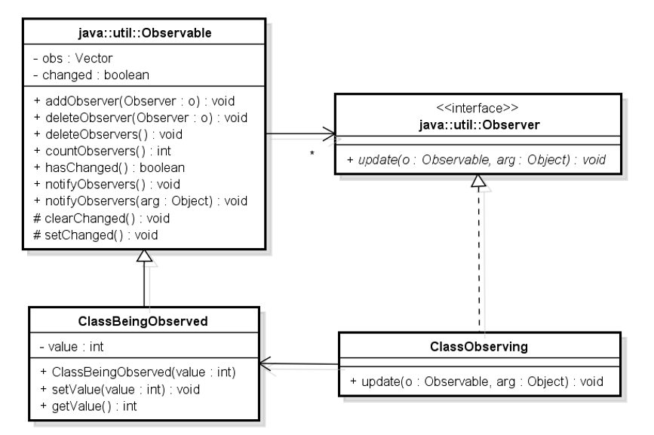

General purpose of observer design pattern:
- Observer automatically updates observing objects when one observable object changes state.
- One-to-many dependency is defined. All observing objects are notified when observed object changes its state.
- General algorithm of observer:
- 1) Subscribe to a service
- 2) Getting a message every time there is an update
- 3) Act upon the update
- In Java:
- 1) addObserver(observer)
- 2) setChanged() and notifyObservers(message)
- 3) observers implement method update(…)
Description of UML diagram:
The pattern has two parts: a subject being observed and observers observing state change in the subject. The subject keeps a list of observers and when the subject's state changes the observers are being notified making a loop and calling method Update for each observer.
The Observer is an abstract interface with an abstract method Update to be implemented in the subclass ClassObserving. It is up to the ClassObserving what to do when a subject calls the update method but as indicated in the diagram this should get the updated state value.
The subject/observable part is the abstract class Subject containing a list of observers and with methods to add an observer to the list, remove an observer from the list and notify all observers, respectively. The subclass ClassBeingObserved handles the logic of the subject without direct information about the observers and with methods changing the state simply calling method Notify in its superclass Subject. The observable side is thereby nicely divided into a general part handling observers with methods independent on the actual subject being observed and a general part with specific information about the subject state.
Our implementation:
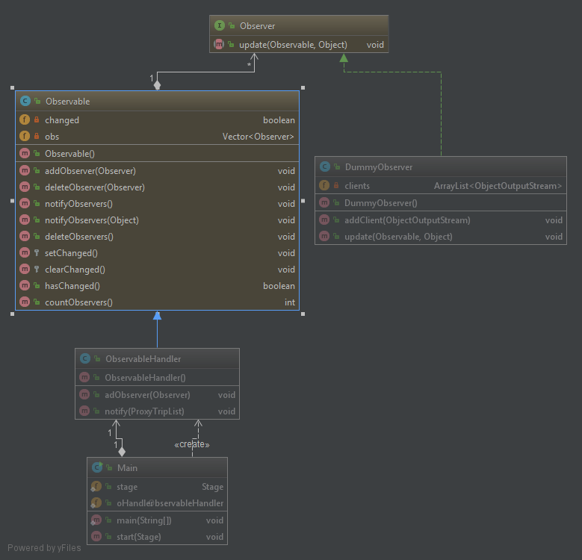

Code examples:
- ObservableHandler class
public class ObservableHandler extends Observable {
public void addObserver(Observer ob){
super.addObserver(ob);
}
public void notify(ProxyTripList trips){
super.setChanged();
super.notifyObservers(trips);
}
}

- Update method from DummyObserver class
@Override
public void update(Observable o, Object arg) {
for (int i=0;i<clients.size();i++){
try {
clients.get(i).writeObject(arg);
clients.get(i).reset();
} catch (IOException e) {
//
}
}
}

- Method addTrip from DataHandler responsible for triggering state change in observable class
public void addTrip(Bus bus, Chauffeur chauffeur, Destination pickUp, Destination destination, int distance, LocalDate startDatePicker, String fieldStartTime, LocalDate endDatePicker, String fieldEndTime, int price, boolean food, boolean accommodation, boolean ticket) {
Trip trip = new Trip(bus, chauffeur, pickUp, destination, distance, startDatePicker, fieldStartTime, endDatePicker, fieldEndTime, price);
if (food) {
trip.setFood(true);
}
if (accommodation) {
trip.setAccommodation(true);
}
if (ticket) {
trip.setTickets(true);
}
trips.add(trip);
Main.oHandler.notify(trips);
}

- DummyObserver is observing class which contains all clients connected to the server. Upon update it send updated trip list (arg) to all of them.
Proxy

General UML diagram for proxy design pattern:

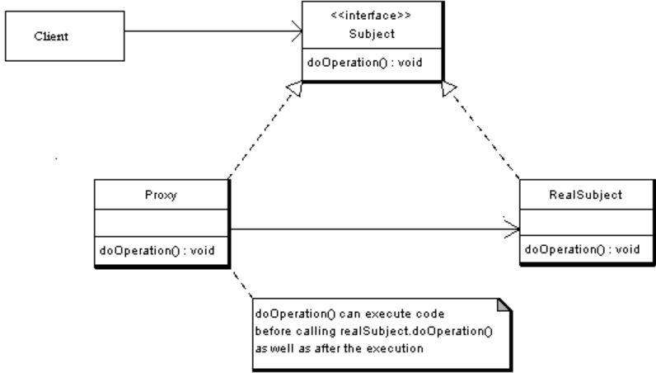

Overall purpose for proxy design pattern:
- Proxy provides a placeholder for another object to control access to it. A wrapper to delegate work to a real subject.
- It can be a thread safe collection delegating work to another collection in synchronized methods, or a client object with access to a model on another computer.
General UML diagram description:
- The Subject is interface implemented by the RealSubject, representing its services. The interface must be implemented by the proxy as well, so that the proxy can be used in any location where the RealSubject is used.
- The proxy has an instance variable from RealSubject that allows the Proxy to access it. Implements the same interface implemented by the RealSubject, so that the Proxy can be substituted for the RealSubject. Controls access to the RealSubject and may be responsible for its creation and deletion.
- RealSubject is the real object that the proxy represents.
Usage of proxy design pattern:
- A client obtains a reference to a Proxy, then the client handles the proxy in the same way it handles RealSubject and therefor invoking the method doSomething(). At that point the proxy can do different things prior to invoking RealSubject - doSomething() method. The client might create a RealSubject object at that point, perform initialization, check permissions of the client to invoke the method, and then invoke the method on the object. The client can also do additional tasks after invoking the doSomething() method, such as incrementing the number of references to the object.
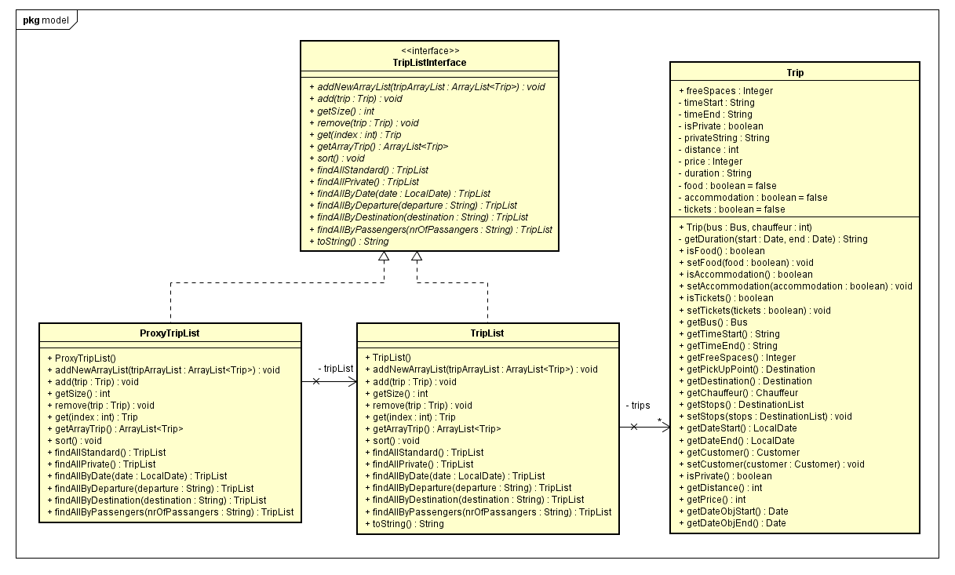
Our implementation:

Code examples:
- Proxy class
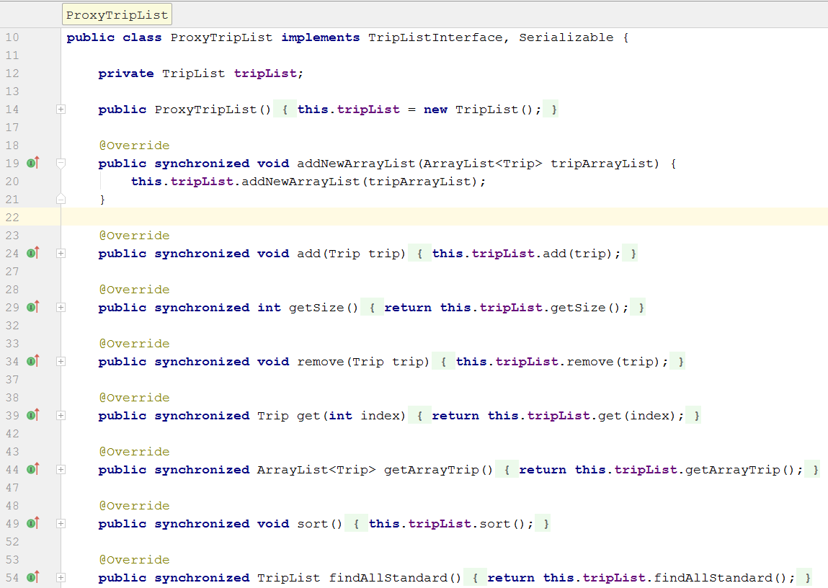

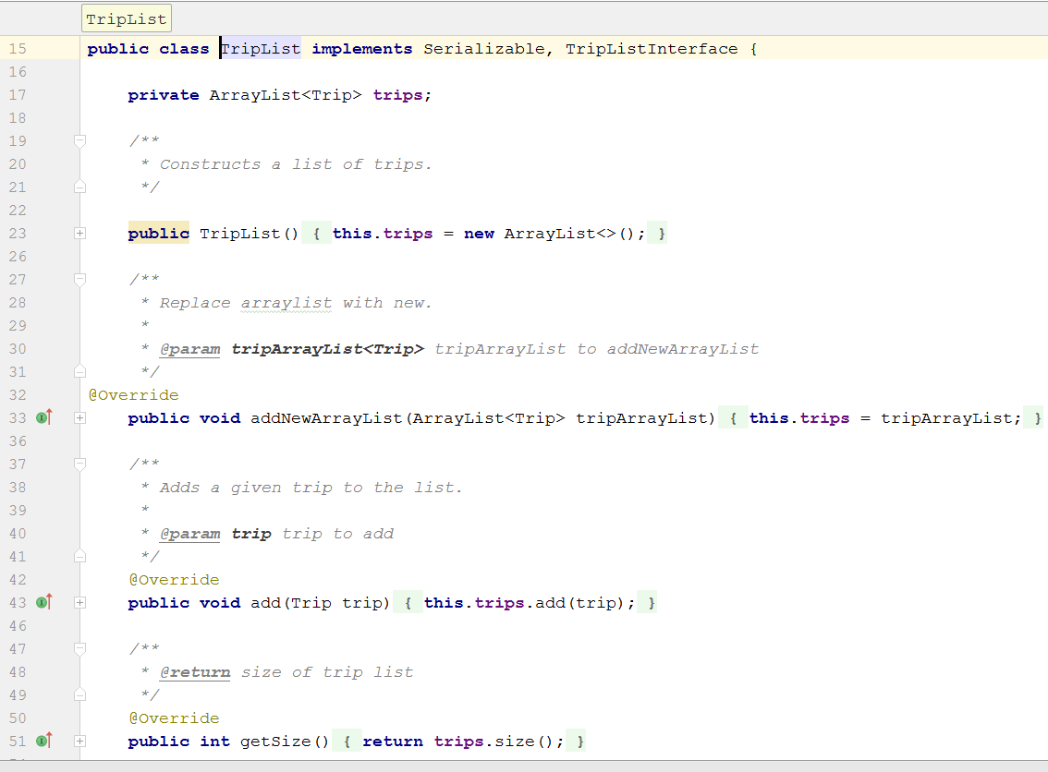
- real class

Iterator design pattern

General UML diagram for iterator design pattern:
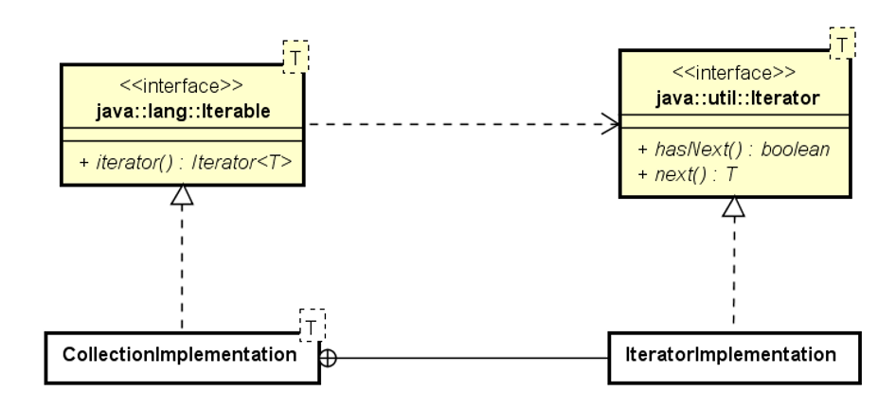

Overall purpose for the Iterator design pattern:
- An iterator is an object that provides the means to iterate over a collection. It provides methods that allow the user to acquire and use each element in a collection in turn. Most collections provide one or more ways to iterate over their elements.

Description of general UML diagram:
- The Iterator interface is defined in the Java standard class library. The two primary abstract methods defined in the Iterator interface are:
  - hasNext, which returns true if there are more elements in the iteration.
  - next, which returns the next element in the iteration.
- There is no assumption about the order in which an Iterator object delivers the elements from the collection. In the case of a list, there is a linear order to the elements, so the iterator would likely follow that order. In other cases, an iterator may follow a different order that makes sense for that collection.
Usage of iterator design pattern:
- Including an Iterator method in the collection, it makes the collection Iterable or in other words, it implements the Iterable interface. The iterator method returns an object that implements the Iterator. The user can then interact with that object, using the hasNext and next methods, to access the elements in the list.
Remarks for iterator design pattern:
- Iterator method boolean hasNext() - returns true if the iteration has more elements. (In other words, returns true if next would return an element rather than throwing an exception.)
- Iterator method E next() - returns the next element in the iteration. Throws: – NoSuchElementException-iteration has no more elements.
Our implementation:
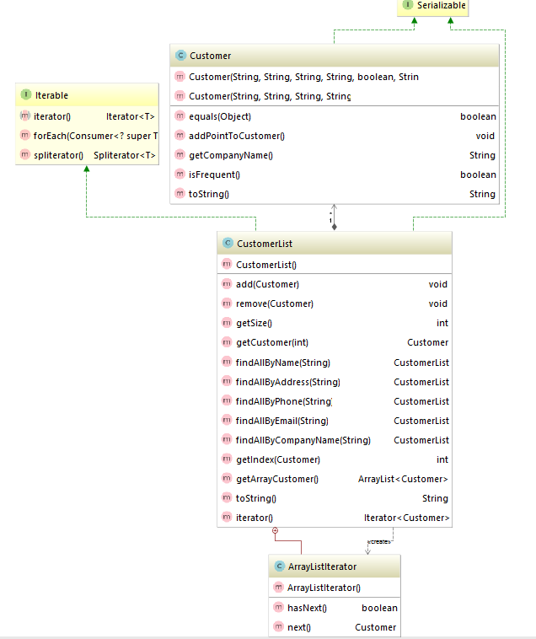

Code examples:
